

SIMATS ENGINEERING
Saveetha Institute of Medical and Technical Sciences Chennai- 602105
Student Name: Amirtha S Reg. No.: 192321074
Course Code: CSA1449 Slot: C
Course Name: Compiler Design for Runtime Environments
Course Faculty: Dr. S. Parthiban, Dr. Arunkumar

Project Title: Domain-Specific Language (DSL) Compiler for IoT Scripting
Module Photographs:
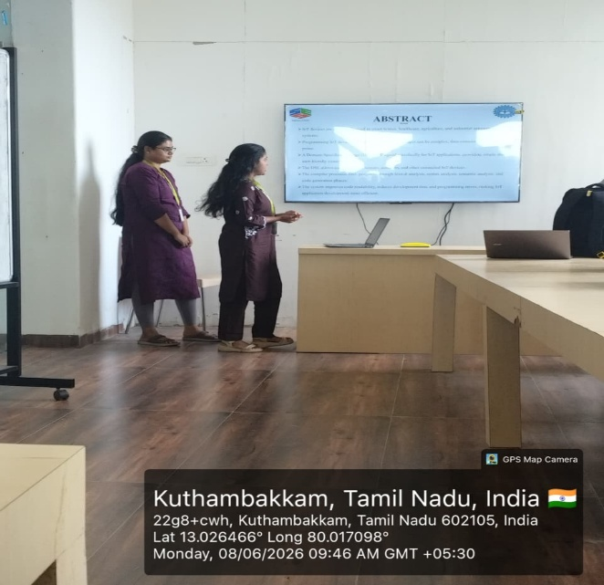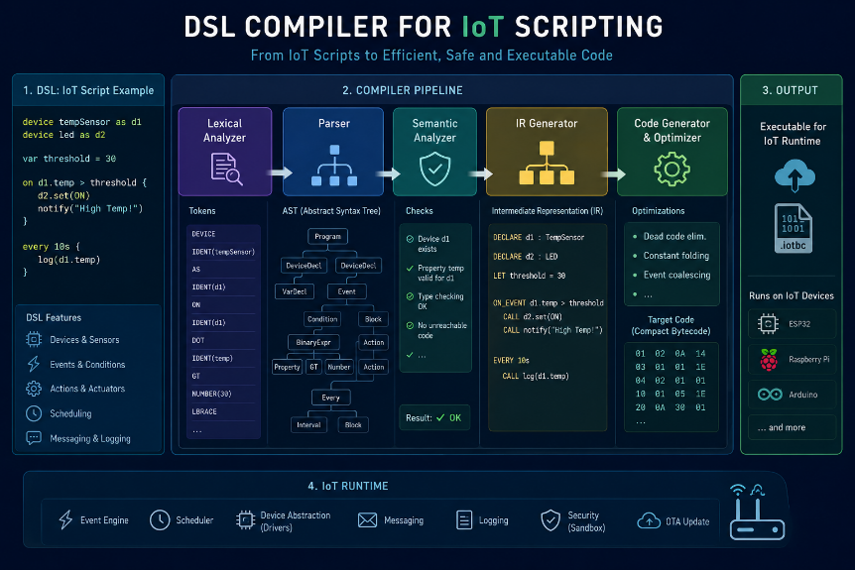
Project Description:
MODULE 2:
SYMBOL TABLE CONSTRUCTION & SCOPE MANAGEMENT

- Create and maintain a symbol table for variables, devices, and functions.
- Store attributes such as name, type, scope, and memory location.
- Handle global and local scopes efficiently.
- Detect duplicate declarations and undeclared identifiers.
- Support scope resolution during semantic analysis.
- Implement symbol lookup and update operations for efficient variable and device access during compilation.
- Manage memory allocation information and track identifier usage for semantic error checking and optimization.

Student Signature Guide Signature

